PROJECT MANAGEMENT
CONSTRUCTION MANAGEMENT
COST ESTIMATING CONSULTANTS

PROJECT MANAGEMENT & CONSTRUCTION MANAGEMENT
MANUAL

2014

TABLE OF CONTENTS

Project Management 3
ASD CONSULTANTS MISSION STATEMENT 3
0.0 PREFACE 4
DEFINITIONS 4
0.1 INTRODUCTION 6
What are the Project Management and Construction Management Programs? 6
Project Management Construction Management Technologies 6
Project Management Documents 6
0.2 Project Services Comparisons (Project Manager vs. Architect) 7
0.2 Project Services Comparisons (Project Manager vs. Architect)(con’t) 8
0.2 Project Services Comparisons (Project Manager vs. Architect)(con’t) 9
0.2 Project Services Comparisons (Project Manager vs. Architect)(con’t) 10
0.2 Project Services Comparisons (Project Manager vs. Architect)(con’t) 11
0.2 Project Services Comparisons (Project Manager vs. Architect)(con’t) 12
0.3 Project Documentation 13
Developing and using daily reports 13
Project logs and registers 13
Memorializing meetings and conversations 13
Schedules and look ahead reports 13
RFIs and contractor initiated proposals 13
0.4 Effective Project Planning 14
0.5 Project Scheduling and Monitoring 15

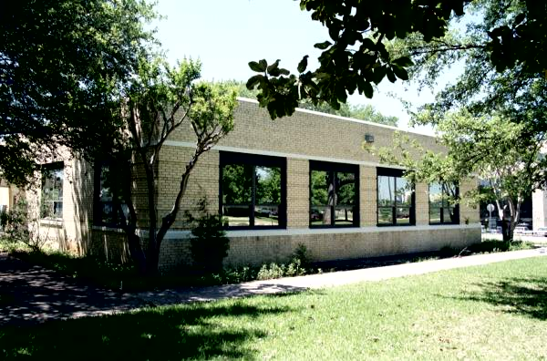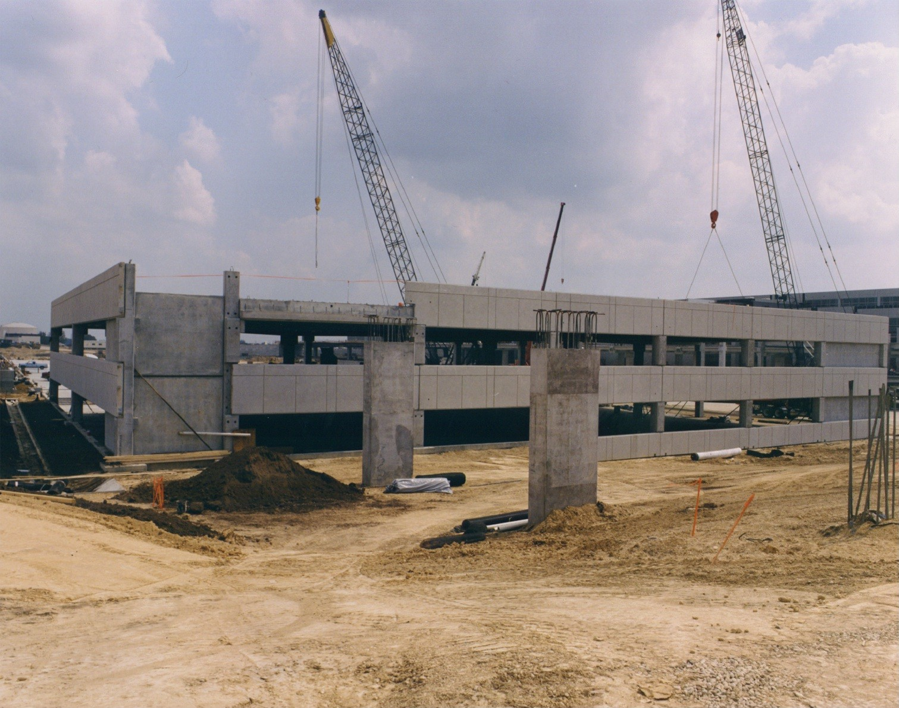

Project Management

ASD CONSULTANTS MISSION STATEMENT

To provide Project Management, Construction Management, and Cost Control Services to our clients.
To provide services that are comprehensive, systematic and affordable to our clients. To utilize the state of the art technologies to manage our clients projects, regardless of the projects size.

To manage our client’s projects to insure the projects are designed within their budget, constructed within their budgets, designed on time and constructed on time. To minimize and/or eliminate our client’s financial exposure to litigation, claims and judgments on their construction projects.

Copyright 1996 - 2002
All rights reserved. No part of this document
may be reproduced in any form or by any
means without prior agreement and written
permission of ASD Consultants, Inc.

ASD Consultants, Inc. is a Texas corporation.

0.0 PREFACE

The General design and Construction climate has led our clients to realize that they need support beyond the general concepts and services provided by Architects and General Contractors. For this reason, ASD Consultants, Inc. has made a concerted effort to develop its project management and construction management procedures to address that need. It is important to keep in mind that, while construction projects tend to share many characteristics, each design and construction effort is unique. The concepts and methods that are communicated through ASD Consultants, Inc. Project Management and Construction Management Program are intended to serve as guidelines to help our clients through the process. We fully expect that some adaptation will be necessary to fit these concepts and methods to each particular situation and the clients’ individual needs.
PROJECT MANAGERS ROLE:
- Manages all aspects for the owner
- Handles all communications
- Tracks Project Finances
- Controls Design

ASD Consultants, Inc. is a consulting firm that specializes in Project Management and Construction Management matters. ASD Consultants, Inc. Inc. Staff has more than twenty years experience in project and construction management. ASD applies the lessons learned as a project manager, architect, and construction manager to the needs of a diverse range of clients.
Construction Managers Role:
- On Site Continuously
- Manages all Construction Related Paperwork
- Services are not a duplication of the services provided by the Architect
- Manages Construction Cost
- Improve Quality

In the course of providing services to our clients, ASD Consultants, Inc. is regularly called upon to review the methods used by Owners and Contractors to manage their design and construction projects. Our experience has allowed us to develop approaches that work and to eliminate those that do not. ASD Consultants, Inc. has come to feel strongly about what causes construction projects to have a successful outcome and we share that experience with our clients. Through our Project Management Program, we seek to make our views and experience available to our clients in a structured and systematic format.

DEFINITIONS
ASD’s only loyalty is to our clients
- We are not designing the Project
- We are not constructing the Project

What is a Project Manager? A Project Manager is a person or firm hired by an owner during the projects conceptual design. The project manager works and is contractually placed between the owner and the architect. The Project Manager helps the owner establish the project's budget and construction budget. The Project Manager represents the Owner in all aspects of the project and all communications with the owner are forwarded through the manager. The Project Manager’s only loyalty is protecting the Owner and insuring that the project is constructed on time and within budget.

What is a Construction Manager? A Construction Manager is a person or firm hired by an owner during the construction of the project. The Construction Manager manages all aspects of the project and manages the information flow. The Construction Manager is on-site continuously insuring the project’s quality, controlling cost and keeping the project on schedule.

What is an Architect? An Architect is a person or firm hired by the owner to design the project. The Architect provides a design, which solves the owners, problems. The Architect provides Construction administration to clarify and interpret the intent of his design. He does not manage the Construction.

ASD Consultants, Inc. main role and purpose in the project is to protect our clients’ interests. Since ASD Consultants, Inc. is not the designer for the project or the contractor for the project; our complete loyalty is to our clients.

ASD Consultants, Inc. project management services are not a duplication of the architect’s services and usually do not result in a significantly higher fee than would be paid for the architects services alone.

This manual will identify the services provided by a Project Manager and Construction Manager and show how they differ from the services provided by the Architect. Most services provided by the Project Manager and Construction Manager are not provided by any other consultant.

ASD Consultants, Inc.

We protect the owner’s interest

0.1 INTRODUCTION

What are the Project Management and Construction Management Programs?

Project Management is a program developed to address the methods for improving the way design and construction professionals manage construction and design contracts. The Project Management program will be communicated through meetings, group presentations and one-on-one presentations. The project management program will be tailored to the needs and interests of individual clients and the project size.

Construction Management is a program developed to address the methods for improving the way construction projects are managed, documented and controlled. The Construction Management program will be communicated through weekly site meetings with the contractors and architects. Status will be communicated through daily reports, photographs, financial reports, and construction schedule. The Construction Management Program will be tailored to the needs and interests of the individual clients and the projects size,

There are certain central themes that will be repeated throughout the Management program. Chief among these is the need for continued communication with the client and exploring ways to deliver the project on time and within the budget. More and more clients are turning toward project management methodologies, and our industry is expanding as the roles between a project manager/construction manager and architect are more defined. This is evidenced by the advent and growth of the industry. Our “client first” approach obviously suggests a departure from many management methods which are inclined to be geared toward either the Architects or the contractors perspective. ASD Consultants, Inc. Management program will address the project from both perspectives with the intention of enhancing the potential savings to our clients minimizing our clients exposure and creating a win-win situation with the architect and contractor.



Project Management Construction Management Technologies
ASD Consultants Inc. utilizes the latest computerized management technologies to manage and track the projects progression with detailed reports, and timely information to our clients. Among these are Timberline©, Prolog©, and Microsoft Office©.

Project Management Documents
- ASD Consultants, Inc. as a standard practice provides its clients with a $2,000,000 professional liability policy to ensure our clients satisfaction.
The ASD Consultants, Inc. Project Management/Construction Management documents and forms are a compendium of individual documents and forms, which cover the concepts and methods that are the framework of the ASD Project Management program. The Project Management/Construction Management documents and forms are intended to be reference documents, which will grow as the program is implemented.

0.2 Project Services Comparisons (Project Manager vs. Architect)

The following is a comparative analysis of the services needed to have a successful project and how a Project Manager/Construction Manager works in conjunction with an owner, architect, contractor, and other consultants. It also shows how services differ and who provides them.

Services Provided by Project Manager |  | Services Provided By  Architect/Owner/Other Consultants
• Works with the client to establish the project’s budget. Works with the client to establish the overall project budget. Budget includes, consultant fees, permits, surveys, fixtures and furnishings and construction. |  | • Normally established by the client or client’s building committee.
• Bids, solicits, negotiates and schedules the owner supplied services:  • Permits  • Surveys  • Geotechnical Services |  | • These services are not provided by the Architect and are the Owner’s responsibility. If the architect assists, there will be an increase in his fees because this is an additional service.
• Perform a site assessment to insure the site does not have any hidden environmental issues that would affect the project’s schedule or budget. |  | • Architects do not provide this service.
• Insure the site is properly zoned and subdivided to accommodate the proposed project. |  | The Architect for an additional fee Can provide •.
• Preparation of the architectural and other consultants agreements written to protect the client. |  | • The client can hire an attorney experienced in construction law to generate a contract which fully protects the client. The client can use the agreement provided by the Architect. The AIA agreement is an agreement that is written to protect the Architect.

- Works with the owner to establish the projects Budget.
- Works with the owner to develop the construction Budget.

0.2 Project Services Comparisons (Project Manager vs. Architect)(con’t)

Services Provided by Project Manager |  | Services Provided By  Architect/Owner/Other Consultants
• Select the best and most qualified architect to design the project by preparing an evaluation criteria and materials to select and evaluate the architectural consultant and his engineers. In addition, the architect’s references are checked and in some cases past projects are visited. |  | • Usually not done by anyone, firms are usually just selected by word-of-mouth.
• Insure that the consultants hired have all the proper licenses and insurance to fully protect the client (i.e. worker’s compensation, consultants liability insurance and consultants errors and omissions insurance) and that the client is listed as an additional insured. |  | • Usually not done by anyone, it is just assumed that every architect has insurance and the client is covered.
• Negotiate and execute the architect’s agreement and insure the agreement protects the client. Some items that protect the client are:  • Non-escalation clauses and cap escalation clauses.  • Clearly identifying what are basic services and what are additional services.  • Clearly identifying the design and construction budget and identifying the repercussions of exceeding that budget. |  | • Negotiations of the fee and definition of the services to be provided is provided by the architect and is usually not negotiated. Normally, if the architect develops the contract, it is written in his favor.
• Clearly identifies the project’s production schedule and the schedule of the entire process. |  | • The Architect clearly identifies the production schedule.
- Help owner select the best Architect
- Negotiates the contract on behalf of the owner
- Ensures the agreement the owner signs is fair

0.2 Project Services Comparisons (Project Manager vs. Architect)(con’t)

Services Provided by Project Manager |  | Services Provided By  Architect/Owner/Other Consultants
• Indicates the number of meetings and/or presentations required or necessary to keep the client informed. Subsequent meetings with the Project Manager will be held to clarify the project and insure the client fully understands it. |  | • The Architect usually identifies the minimal number of meetings and/or presentations he deems necessary, any meeting over and above that number will be charged as an additional service.
• Provides an unbiased review of the plans and specifications to insure the client’s requirements are being addressed. Verifies that the project is within the budget. Each submission is reviewed for the same issues. Thoroughly discusses the issues of the project with the client. |  | • The Architects submits the documents to the client for review and comments.
• Provides unbiased pros and cons on the project’s design and provides information to the client to enable the client to make informed and timely decisions, which are critical to the entire process. |  | • Provides general information on the project and focuses on the important design issues.
• Insures the language is included in the project to totally protect the client during the construction phase. Items typically include:  - Workman’s Compensation  • Performance Bonds  • Labor and material bonds  • Liquidated damages  • Liability insurance  • Automobile insurance  • List of similar projects and references  • Financial status |  | • Some of the items may be included, but it depends on the Architect’s experience and budgetary concerns.  - The Project Manager ensures language is included in the contact documents to protect the owner
• Oversees the advertisement of the project for bids. Insures the process will get the maximum number of bidders. |  | • The Architect will assist the client in preparation of the advertisement.
• Represents the client at the pre-bid conference and answers questions related to the client’s desires. Provides minutes of the meeting. |  | • The Architect conducts the pre-bid conference and addresses all technical questions related to the project design.

0.2 Project Services Comparisons (Project Manager vs. Architect)(con’t)

Services Provided by Project Manager |  | Services Provided By  Architect/Owner/Other Consultants
• Analyzes bids, looking for the lowest, most qualified bidder that meets all requirements.  - Recommends the lowest most qualified bidder |  | • The Architect analyzes bids, looking for the lowest bid. His opinions may be biased; remember, if the bid exceeds the architect’s estimate, he has to redesign, so he may select a firm simply because the bid is lower than his estimate.
• Attends pre-construction conference, reports back to the client and provides minutes. Works out logistics such as:  • Start date • Staging area  • Utilities • Telephones  • Restrooms • Etc. |  | • Conducts pre-construction conference, works out logistics. i.e. start date, working hours, construction schedule.
• Provide construction management - on-site continuously.  - Takes construction photographs daily  - Prepares daily field reports  - Observes contractor’s safety practices  - Inspects building materials and products to insure no asbestos or lead products are being used.  - Documents work process in accordance with schedule  - Documents contractor’s work effort, to insure he has adequate personnel on staff and on- site.  - Observes contractors quality of work and will direct poor quality work to be redone, to protect and keep manufacturers’ warranties valid.  - Insure project milestones are met.  - Provides quality control and orders additional testing if required.  - Meets with clients as needed to keep them informed.  - Construction Manager is on site continually  - Documents the entire construction process |  | • Provides construction management visits, site weekly or if problem arises.  - Does not provide  - Provides reports of weekly site visits.  - During weekly visits  - Does not provide  - Architect provides this service  - Documents during his weekly visits  - Observes work in accordance with plans and specifications during his weekly visits.  - Does provide this service  - Does not provide this service  - Usually have a predetermined number of meetings; any meetings over that amount would be at an additional cost.

0.2 Project Services Comparisons (Project Manager vs. Architect)(con’t)

Services Provided by Project Manager |  | Services Provided By  Architect/Owner/Other Consultants
• Reviews all requests for change orders from a non-biased view. Whose fault is it? - the architect or contractor? Insures the appropriate person is held accountable and bears or shares in any additional costs. |  | • Reviews change orders (normally from a biased point of view to protect himself).
• Reviews contractor’s request for time extension. Whose fault is it? - the architect or contractor? |  | • Review contractor’s request for time extensions from a biased point of view (to protect himself).
• Attends the project’s final walk-through and generates a punch list. |  | • Attends the project’s final walk-through and generates a punch list.
• Insures the client’s personnel have been thoroughly trained on the operation of all new equipment. |  | • Does not provide this service.
• Insures all as-built drawings; manuals, warranties and keys are turned over to client. |  | • Will assist (as needed).
• Assists in the one (1) year warranty |  | • Assists in the one (1) year warranty up to a specific number of hours normally identified in the contract.
• Assists and coordinates the client’s purchasing and delivery of owner provided items. The key is to schedule the delivery of items when the project is ready to accept them, in order to avoid having to store items. Typical items that are owner provided:  1. Signage 8. Piano (*)  2. Special lighting fixtures 9. Organ (*)  3. Drapes and blinds. 10. Artwork  4. Office furniture 11. Clocks  5. Pews (*) 12. Trash cans  6. Plants 13. Appliances  7. Special equipment |  | • Does not provide this service  - The Project Manager assists the owner in securing the other projects and equipment needed for the project
(*) Items required for Churches

0.2 Project Services Comparisons (Project Manager vs. Architect)(con’t)

Services Provided by Project Manager |  | Services Provided By  Architect/Owner/Other Consultants
• Assists in scheduling the grand opening - i.e. assists in the design of plaques, signs, setting dates etc. |  | • Does not provide this service
• Provides overall financial tracking for project:  - Total amount of budget  - Amount expended to date on all consultants  - Amount of additional services to consultants  - Amount expended to date on the contractor  - Amount of change orders to the contractor  - Amount expended on furniture and fixtures.  - Maintains and reports all expenditures. |  | • Does not provide this service
• Provides these financial reports two times a month to keep the client informed of the project’s financial status. |  | • Does not provide this service.
• Insures expenditures match the amount of work done by the consultants and the contractor. |  | • Does provide this service for the contractor only.
• Tracks the project’s overall schedule (design and construction).  - Rain days  - Time extensions |  | • Does provide this service for the contractor.

- Provide Reports
  - Daily with Photos
  - Financial
  - Schedules
- For Architect and the Construction Manager

0.3 Project Documentation

Developing and using daily reports

No single type of documentation is more important than daily reports. This documentation is critical in having a chronological history of the project. This documentation is also critical in warranty requests or litigation.

Project logs and registers

Keeping track of documents is a vital part of good project management. ASD Consultants, Inc. has developed systems to log and track all project documentation and correspondence, such as, RFIs, submittals, drawings, changes and contractor or consultant initiated proposals.

Memorializing meetings and conversations

ASD Consultants, Inc. Project Management program realizes the importance of keeping accurate notes of meetings and phone conversations and how to integrate these notes into the project documents. Our company also realizes the importance of keeping a diary of the events and pertinent conversations of the day.

Schedules and look ahead reports

ASD Consultants, Inc. Project Management Service realizes the role of schedules in the overall project documentation effort. Our service has developed techniques for generating usable schedule information, for indicating the methods and frequency of schedule updates and the role of coordination for meetings.

RFIs and contractor initiated proposals

ASD Consultants, Inc. recognizes the importance of Requests for Information (RFIs) from the perspective of how they can be used to benefit the contractor and the client.

- Utilizes “Prolog Manager”, to computerize Project Management Data Base.
- Utilizes “Timberline”, to computerized cost estimating system to track and analyze cost.

0.4 Effective Project Planning

Developing a valid work plan

ASD Consultants, project manager process requires that a sound work plan be formulated. The work plan discusses the key elements (i.e. team participation, estimate to budget translation and resource evaluation).

Pre-construction planning sessions

ASD Consultants, Inc. realizes that one of the project’s focal points in the planning effort is the pre-construction planning meeting. Our process provides a system for organizing the meeting, developing checklists for use in the meetings and evaluating methods to be used to gauge the planning effort.

How to communicate, execute and monitor the work plan

ASD Consultants develops a project-planning network and a responsibility matrix to help communicate, execute and monitor the work plan.

0.5 Project Scheduling and Monitoring

Getting the most from scheduling

ASD Consultants, Inc. realizes the importance of scheduling and has developed fundamental elements to generate an effective effort.

Basic schedule development

ASD Consultants, Inc. management effort includes the process of transforming the work plan into a master schedule. The schedule will include scope review, resource consideration, use of network scheduling and much more.

Implementation of the scheduling effort

Once ASD Consultants, Inc. works to develop the master schedule, and outlines the steps, the scheduling continues throughout the life of the job. These are steps that must be taken to insure that the scheduling effort provides all its potential benefits.

